RATIONAL WAY TO ESTIMATE VELOCITIES OF EARTHQUAKE-INDUCED DEBRIS FLOW FROM SUPER-ELEVATIONS

M.A. Rahman ⁽¹⁾, K. Konagai ⁽²⁾

- PhD Candidate, Graduate School of Urban Innovation, Yokohama National University, Japan, e-mail: maftabur@gmail.com
- Professor, Graduate School of Urban Innovation, Yokohama National University, Japan, e-mail: konagai@ynu.ac.jp

Abstract
Estimation of debris flow velocity based on Forced vortex equation by using the super-elevation is a conceivable approach in earthquake-induced geo-hazard studies. A super-elevation can be seen through a curved trail of debris flow, where the centrifugal force is responsible for the higher flow depth on the outer bend. Post-flow field investigation is the solitary way to measure the super-elevation at certain cross-sections. However, only the remnant flow-marks are visible, which can mislead the actual velocity of the flow. Highlighting this problem, a series of numerical simulations using the Smoothed Particle Hydrodynamics (SPH) are carried out to check the aptness of applying flow-marks in the debris flow velocity estimation. Velocities from flow-marks underestimate actual velocities near the source region, while they converge on real velocities as the distance to source increases. Afterward, numerical results are justified with the one well documented real debris event called “Shiraito river debris flow”, which happened near the rim of Hakone Crater, Kanagawa prefecture, Japan, ensuing from the 1923 Great Kanto earthquake.
Keywords: Super-elevation; debris flow velocity; mud-marks; SPH

Introduction
Debris flows are defined as very rapid to the extremely rapid flow of saturated debris in a steep channel [1]. This type of natural disaster is usual in mountainous countries. Intense earthquake and torrential rainfall are the main sparking factor for the initiation of debris flows. Sometimes, volcanic eruption can also result in muddy destructive debris flows. 213 major debris flow disasters with 77779 fatalities have been reported in academic papers, newspapers and corresponding authorities [2].
Debris flows are hazardous because of their rapid onset, high impact force and deposition of large amounts of sediments in the alluvial fan. Development of apposite mitigation strategy requires the intensive study of the dynamic features of debris flows. Peak discharge, volume, impact force, velocity, material characteristics is some of the substantial parameters. Among them, velocity of flowing mass is of paramount importance in the mitigation measure as this parameter affects the impact force, run-up distance and time taken to reach the deposition area. Therefore, using an appropriate methodology to estimate the flow velocity is prerequisite for debris hazard prevention. However, there is no straight forward rules in estimating flow velocities. So far, post-event field investigation of super-elevation along the curved flume is the widely used technique for the estimation of velocities. Yet, field survey only portrays circumstantial evidences of debris flow velocities, and due attention has not been paid so much on this difficulty in technical literatures. Thus, this paper describes the problems in reality of estimating velocities, a series of numerical simulations to improve the existing procedure, and one example of implementing numerical findings in analyzing real debris flows.

Background of the study
A debris mass leaves mud marks along its flow path, and when it travels through a curved channel, the height difference between mud marks on inner and outer walls, referred to as super-elevation, appears (Fig.1). Usually, velocities are estimated from the observed super-elevation using the Forced Vortex equation given below which equates fluid pressure to centrifugal force [3].
$$v=\sqrt{\frac{g×R×∆h}{k×b}\cos{α}}$$
Where, $R$ = radius of curvature of bend, $∆h$= super-elevation, $b$= width of channel section, $g$= gravitational acceleration, $α$=channel inclination, $k$=correction factor for viscosity. This equation derives for pure water flows based on simplified assumptions. However, correction factor $k$ is introduced to account for viscous nature and vertical sorting/segregation within the slurry.
Fig.1 Curved stretches Ontake avalanche in Japan (Occurred on Sep 14, 1984) and sketch of super-elevation (Image taken from Google Earth)
Post - event survey requires to measure the curvature and super-elevation at a certain section of flow trace. Appropriate selection of bend radius is quite difficult in field because any natural channel is hardly a perfect circle, rather has a varying curvature. However, the critical issue is to measure the super-elevation correctly. Yet, only the highest flow marks on each side of the channel are visible, which does not reflect the actual image. Moreover, splashes and hydraulic jumps sometimes leads in erroneous measurement of super-elevation. These glitches of mud-marks estimation can misread the actual velocities. In-situ scenario is also justified with large scale flume test conducted by the USGS which revealed that velocity using super-elevation underestimate the actual velocity by 30% [4].
A realistic approach for plausible estimation of velocities is therefore necessary for practical engineers. Though a flume tests can be very pertinent to spur your thinking, a real scale debris flow test is often cumbersome. Furthermore, complete similarity (geometrical, kinetic & dynamic) in an experimental study requires different viscous materials which is close to impossible. In light of limitation of the experimental investigation, these large scale problems are now-a-days modeled numerically and can provide better agreement with the real situation. Thus, highlighting the shortcomings of in-situ situation, this research simulates a series of numerical curved flume test for velocity estimation and subsequently, numerical outcomes are justified by the real debris flow event in Japan.

Numerical Modeling
Advancement of high computing tools up-surged the numerical simulation of debris flow over the last decades. Both grid-based and mesh-free methods have been widely used in recent years for modeling debris flow dynamics. However, large-deformation behavior of debris materials favors the use of mesh-free particle methods. Recently, numerous particle based methods are used in analyzing the dynamic features of debris flows. Among the various mesh-free method, Smoothed Particle Hydrodynamics (SPH) is a good choice for modeling debris flows and used in this research study. SPH was initially developed for astrophysical problems [5] and later extended it into the diverse field, including hydrodynamic problems and large deformation analysis. It can track the motion of each particle, accurately predict the velocity and naturally handle the free surface flows. Complicated geometrical modeling can also be done easily in this numerical approach as there is no connectivity between particles.
In SPH, the problem domain is described by a set of arbitrary particles without any connectivity which makes it purely Lagrangian in nature. Each particle has a specified area and contains its physical properties. Particles update their properties from their neighboring particles using a smoothing kernel function and mass and momentum equations are solved in each time step. Finally, a time stepping algorithm is used to update their positions. Detail features of SPH are available in [6].

Modeling of curved flume
A 3D curved flume was modeled using the SPH numerical scheme based on scaling analysis considering geometric, kinetic and dynamic similarities. Comparison between scaled and prototype model suggested the rationality of using this numerical model despite the fact that numerical simulations were consummated in an idealized and simplified manner. Layout of the curved flume is illustrated in Fig.2.
Fig.2 Layout of curved flume
From the upstream to the lower stream ends, the flume has a reservoir at the upstream end, a length-changeable straight section, an upper curved portion, the second straight channel and a lower curve. The reservoir having the dimension of 675 x 270 x 450 mm was outfitted with a gate and sudden removal of gate initiated the debris flow in a dam break fashion. The upper straight section length was varied in each simulation to check the effects of super-elevation on velocity estimation at different distances from the source region. Two different bend radius of 500mm and 750mm were chosen for the study. Inner and outer depth of flow along the curved portion of the flume were stored at every 0.1 Sec interval. Lagrangian parameters of particles were set at the appropriate values considering law of similarities and given in Table.1.
Defining material characteristics of debris material is an important parameter of numerical modeling. In reality, debris material is a complex mixture of water, clay and granular materials. Often, this flow consists of uprooted trees, houses, blocks and many other things. Thus, constitutive modeling of debris material is challenging and truly speaking, naturalistic modeling is close to impossible. Hereafter, researchers simplified debris material modeling and most of the cases, debris slurry is modeled as a single viscous component. Non-Newtonian Bingham model having a yield strength can replicate the behavior of debris flows and used in this study. Equivalent Newtonian viscosity for Bingham model [7] is widely used for its simplicity and satisfactory results and equation is written in the following form.
$$μ^{/}=\left\{\begin{matrix}μ_{0}+\frac{τ_{y}}{\dot{γ}} & if μ^{/}<μ_{max} \\ μ_{max} & otherwise\end{matrix}\right.$$
where, $τ_{y}$ is the yield strength, $μ^{/}$ is the equivalent viscosity and $\dot{γ}$ is the shear strain rate. The Bingham constitutive law was used for modeling the debris materials
Table 1. Parameters and scaling consideration of curved flume
Parameters | Model (1/40 scale) | Prototype | Unit
Initial volume | 0.675 x 0.270 x 0.450 | 27.0 x 10.8 x 18.0 | m
Distance to upper curve | 1.5~4.5 | 60~180 | m
Viscosity | 0.5 | 126.5 | Pa.s
Channel slope | 15 | 15 | degree
Time | 15.0 | 94.0 | sec

Results and discussion
Total 14 numerical curve flume tests were run in this research works. Parameters were set considering the scaling laws. However, in the real debris flow event, viscosity of flowing mass is highly uncertain and needs to be taken into account. Thus, Selection of appropriate viscosity in debris flow modeling is necessary for conceivable results. From that viewpoint, a small scale straight flume test with different viscosities were simulated prior to the curved flume test. Viscosities were kept between 0.01-10.0 Pa.s which is compatible with real debris flow events. Flow velocities and surge front for different viscosities were recorded and are shown in Fig.3. Surge front and velocities didn’t exhibit any unexpected variation and hence, subtly revealed the minor effects of viscosity on the velocities.
Fig.3 Effect of viscosities, (a) time history of surge front, (b) time history of front velocities
Higher flow depth of the outer bend was seen along the curved portion of the channel owing to the centrifugal force. The difference in elevation between outer and inner depth define as super-elevation and this super-elevation was recorded at every 10$°$ apart. However, post-flow site investigation only identifies the flow marks that left after the event which eventually corresponds to the highest flow depth at both inner and outer bend. Field derived super-elevation, thus does not reflect the actual super-elevation of the flow. To account the realistic scenario, only the highest flow marks were used to calculate super-elevations in the numerical model. Afterward, velocities were estimated using this super-elevations. A series of simulations was run by changing the position of upper curve to cover the wide range of variation of velocities and other properties. Velocities from highest mud-marks (V_{mud}) were then normalized with the actual velocities (V_{obs}) at the particular section and discussed with normalized distance. Distance of the selected sections were normalized using an initial source length considering the practical point of view. However, before using initial source length as normalized parameter, a sensitivity analysis of using different aspect ratio is needed.
Fig.4 Effect of initial aspect ratio (a) velocities over time at surge front, (b) velocities at normalized distance 0.5, (c) velocities at normalized distance 1.0
Aspect ratio is defined as the ratio of initial source height to length. This ratio is usually smaller or equal to 1.0 for most of the real debris event, though several high position debris flow disasters were occurring in different mountainous areas. For the sensitivity analysis, source length was varied, keeping the same height of the initial deposit to check the aptness of using source length as normalizing parameter. Small scale numerical simulations of straight flume were carried out to check the flow characteristics for different aspect ratios and outcomes are plotted in Fig. 4. Fig.4 depicts the time-history of velocities at the same normalized distance (surge front/initial source length) of the flume for each aspect ratio. Surge front velocities shown in Fig. 4(a) does not portray any enormous change of velocities for various aspect ratios. Moreover, clearer images of velocities can be substantiated by Fig. 4(b) and Fig. 4(c) which shows the consistent change of velocities at normalized distance 0.5 and 1.0, respectively. As the main concern of the current research is velocity estimation and no momentous change of velocities were perceived, it can be implicitly said that the effect of aspect ratio on the outcomes of numerical modeling is less significant. Hence, the initial source length can be chosen as normalizing parameter for distance.
Lastly, normalized distances and velocities were plotted and shown in Fig.5. Uncertain, turbulent characteristics of the flowing mass leads to the scatter plot of velocities and distances. Yet, closely, seeing the relation in Fig.5 reveals higher values of the normalized velocity cluster as the distance to source increase. An exponential fitting line was then determined assuming that the normalized velocity converges on 1.0 with increasing distance. This fitting line can be used to adjust the field estimated velocities and verification is needed prior to use it for practical purposes. To do so, one documented debris flow event in Japan was selected and verified in the subsequent section.
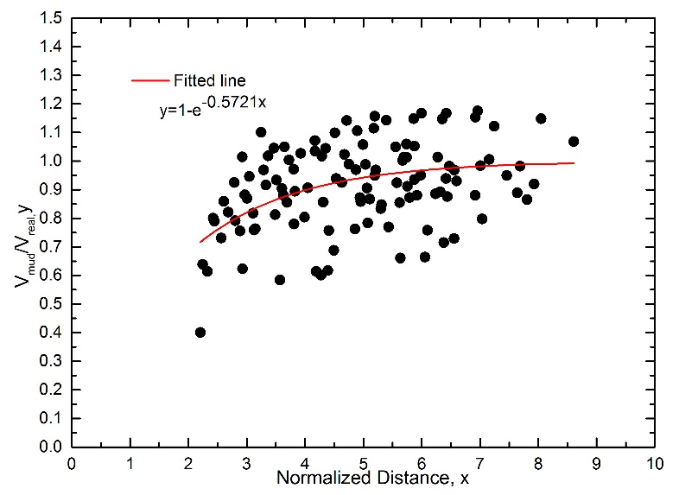
Fig.5: Normalized distance and velocity relationship

Verification example
A massive debris avalanche near the rim of Hakone crater, Kanagawa prefecture, Japan was occurred immediately after the Great Kanto Earthquake of 1923.The detached mass ran down the Valley of Shiraito River in a thick cloud of dust and rushed into the Nebukawa town with thunderous roar breaking and burying houses along the flow path. Detail description of this disaster is described in [8]
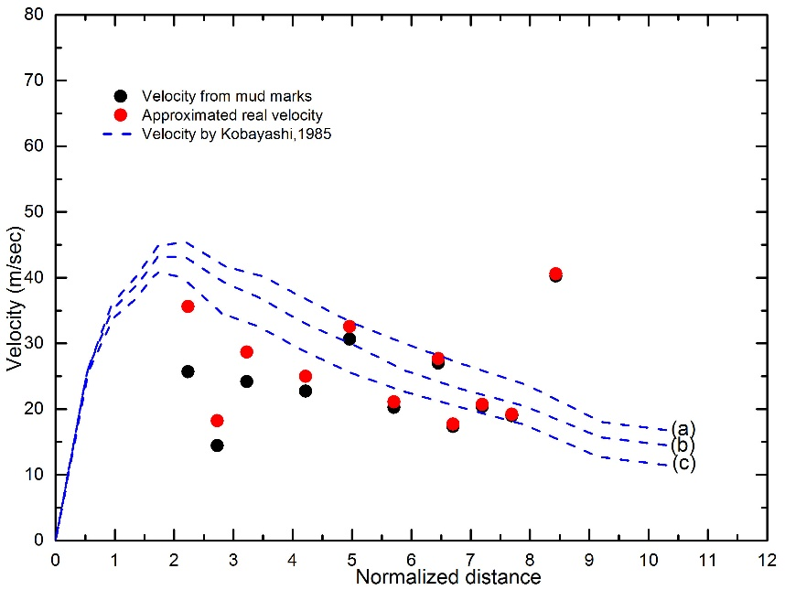
Fig.6: Adjusted velocities for Nebukawa debris disaster
Precise drawing of flow marks on the left and right banks of Shiraito River by Mr. Kazumasa Uchida exists in the Kanagawa Prefecture Archives. These flow marks were used to estimate the velocities, which were then adjusted with the numerically obtained exponential fitting line and plotted in Fig.6. Adjusted velocities were further compared with Kobayashi’s [9] result which is based on Saint-Venant hypothesis for a one-dimensional non-Newtonian flow with the inclusion of an additional friction slope term. These velocities exhibit quite compatible agreement with Kobayashi’s results as well as the scenario estimated from verbal evidences reported in technical literatures.

Conclusion
The proposed simplified adjustment of mud-marks-based debris flow velocities yielded a consistent result with the scenarios for a real debris flow disaster estimated from both verbal evidences and Saint-Venant hypothesis for a one-dimensional non-Newtonian flow. However, this simulation is based upon the simplified channel configuration and further development may refine the outcomes. Yet, proposed numerical modeling realistically simulates the debris flow velocities despite the several shortcomings of the model.

References
[1] Hungr O, Evans SG, Bovis MJ, Hutchinson JN (2001): A review of the classification of landslides in the flow type. Environmental and Engineering Geoscience, VII(3), 221-238.
[2] Dowling CA, Santi PM (2014): Debris flow and their toll on human life: a global analysis of debris-flow fatalities from 1950 to 2011. Nat Hazards, 71, 203-227.
[3] McClung DM (2001): Super-elevation of flowing avalanches around curved channel bends. Journal of Geophysical Research, 106 (B8), 16489-16498.
[4] Iverson RM, LaHusen RG, Major JJ, Zimmerman CL (1994): Debris flow against obstacles and bends: dynamics and deposits. EOS, Transactions of the American Geophysical Union, 75(44),274
[5] Lucy LB (1977): Numerical approach to testing the fission hypothesis. Astronomical Journal, 82, 1013-1024.
[6] Liu GR, Liu MB (2003): Smoothed Particle Hydrodynamics: A mesh free Particle Method. World Scientific Ltd., Singapore.
[7] Uzuoka R, Yashima A, Kawakami T, Konrod JM (1998): Fluid dynamics based prediction on liquefaction induced lateral spreading. Computational Geotechniques, 22(3/4), 234-282.
[8] Rahman MA, Hashimoto T, Konagai K (2015): An attempt for velocity estimation of Nebukawa debris flow triggered by the Great Kant Earthquake, 1923. Journal of Japan Society of Civil Engineers, Ser. A1 (SE/EE), 71(4), 387-394.
[9] Kobayashi Y (1985): A catastrophic debris avalanche induced by the 1923 Great Kanto Earthquake. Natural Disaster Science, 7(2), 1-9.

